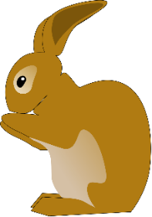  Rabbit Class Spring Term  Please bring in your water bottle daily, this will be sent home for washing at the end of each day.  PE Days:  Tuesday and Thursday - Please come to school in your PE kit.  Reading Books:  Reading books will be changed every Monday and Thursday. Children should read at home daily.  Times Table Rock Stars:  Children should be practising their 2, 5, and 10 times tables by accessing the TTRS website at home, at least twice a week. Login details can be found in planners.  Focus for our learning this term:  English: poetry, recounts from personal experience, formal invitations, stories from other cultures, non-chronological reports.  Maths: Time, fractions, adding and subtracting 2 digit numbers, money, shape and pattern.  Geography: Compare the UK to a non-European location: Kenya.  History: Significant events, people and places in Newmarket’s past.  Science: Everyday materials and their uses. | Rabbit Class Spring Term  Please bring in your water bottle daily, this will be sent home for washing at the end of each day.  PE Days:  Tuesday and Thursday - Please come to school in your PE kit.  Reading Books:  Reading books will be changed every Monday and Thursday. Children should read at home daily.  Times Table Rock Stars:  Children should be practising their 2, 5, and 10 times tables by accessing the TTRS website at home at least twice a week. Login details can be found in planners.  Focus for our learning this term:  English: poetry, recounts from personal experience, formal invitations, stories from other cultures, non-chronological reports.  Maths: Time, fractions, adding and subtracting 2 digit numbers, money, shape and pattern.  Geography: Compare the UK to a non-European location: Kenya.  History: Significant events, people and places in Newmarket’s past.  Science: Everyday materials and their uses.

