EMOTIONALWELLBEING
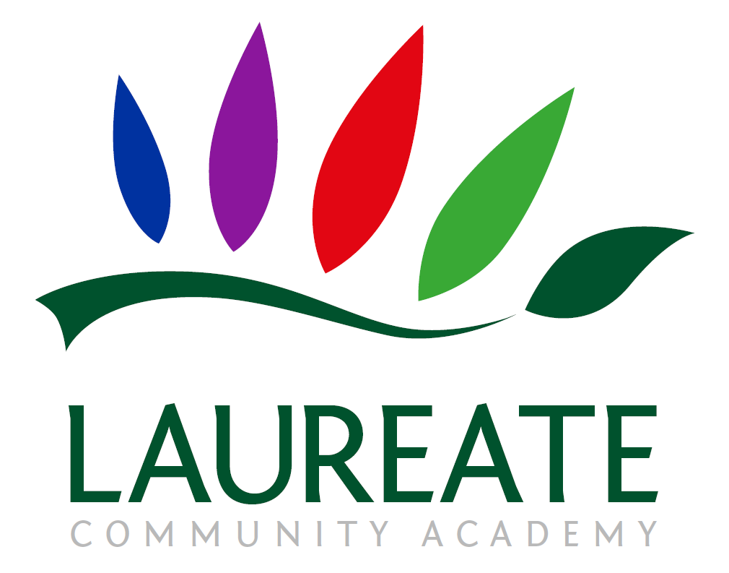

A GUIDE TO SUPPORTING YOUR CHILD IN SCHOOL AND AT HOME

Updated October 2023
Introduction
All of us have mental health. However, the proportion of children and young people who experience mental health difficulties has been widely reported in recent years, and is sadly increasing:
- 1 in 10 children and young people aged 5-16 suffer from a diagnosable mental health disorder
- Between 1 in 12 and 1 in 15 children and young people deliberately self-harm
- The proportion of young people being admitted to hospital because of self-harm has increased by 68% over the last 10 years
- More than half of all adults with mental health problems were diagnosed in childhood, but less than half were treated appropriately at the time
- Nearly 80,000 children and young people suffer from severe depression
- The number of young people aged 15-16 with depression nearly doubled between the 1980s and the 2000s
- Over 8,000 children aged under 10 years old suffer from severe depression
- 3.3% (or about 290,000) children and young people have an anxiety disorder
- 72% of children in care have behavioural or emotional problems - these are some of the most vulnerable people in our society
We are passionate about supporting all of our pupils and families to have positive mental health, now and in the future. This booklet includes:
- Links to information and guidance about the issues most commonly seen in school-aged children
- An explanation of how we teach and promote positive mental health in school, and how we will support your child if they are experiencing mental health difficulties
- How you can support your child (and yourself) at home
If there is anything that we can do to support your child or family, please do not hesitate to contact me or another member of our team.
Mr D Perkins
Senior Mental Health Lead & Headteacher
Warning signs that your child may have mental health difficulties
You may become aware of warning signs which indicate a pupil is experiencing mental health or emotional wellbeing issues. Possible warning signs include (but are not limited to):
- Physical signs of harm that are repeated or appear non-accidental
- Changes in eating or sleeping habits
- Increased isolation from friends or family, becoming socially withdrawn
- Changes in activity and mood
- Lowering of academic achievement in school
- Talking or joking about self-harm or suicide
- Abusing drugs or alcohol
- Expressing feelings of failure, uselessness or loss of hope
- Changes in clothing, e.g. long sleeves in warm weather
- Secretive behaviour
- Skipping PE or getting changed secretively
- Lateness to, or absence from, school
- Repeated physical pain or nausea with no evident cause
- An increase in lateness or absenteeism

Talking to your child about their mental health
It can feel difficult if your child tells you that they are struggling with their mental health. The first thing to remember is how great it is that they can tell you. Below are some tips that you may find helpful, in what can feel a tricky time.
Focus on listening
Listen and let them do the talking. Ask occasional open questions to let them know that you have heard them and want to understand them, and to validate their feelings. Just letting them pour out what they’re thinking will make a difference and is their first step in recovery. Up until now, they may not have admitted even to themselves that there is a problem.
Try not to talk too much
Your child should be doing most of the talking. Sometimes the conversation may lapse into silence, but try not to give in to the urge to fill the gap. This can often be helpful for them in exploring their feelings more deeply. Of course, you could interject occasionally, to show that you understand and are being supportive. Try not to feel an urge to overanalyse the situation or try to offer answers. This all comes later. For now, they just need a supportive listener.
Acknowledge how hard it is to discuss these issues
Sometimes it can take a child weeks or even months to admit to themselves they have a problem, and sharing it can be a big thing. When your child chooses to confide in you, you should feel proud and privileged that they are able to let you know. Acknowledge both how brave they have been, and how glad you are that they have spoken to you.

Don’t pretend to understand
The concept of a mental health difficulty such as an eating disorder or obsessive compulsive disorder (OCD) can seem completely alien if you’ve never experienced these difficulties first hand. Listen hard to what they’re saying and encourage them to talk and you’ll slowly start to understand what steps they might be ready to start taking.
Offer support
Try not to leave this kind of conversation without agreeing next steps. Whatever happens, you should have some form of next steps to carry out after the conversation because this will help your child to realise that you’re working with them to move things forward. Even though your child has confided in you and may even have expressed a desire to get on top of their illness, it doesn’t always mean they’ll readily accept help yet. They may resist any form of help for as long as they possibly can. It may have been enough to let you know at this point.
Never break promises
Above all else, your child wants to know they can trust you. That means if they want you to keep their issues confidential and you can’t then you must be honest. You can also be honest about the fact you don’t have all the answers or aren’t exactly sure what will happen next. Consider yourself your child’s ally rather than their saviour and think about the next steps you can take together.

School based support
We aim to do all we can for support our pupils to have positive mental health. Way in which we do this include:
- Personal, Social and Emotional Development is an important area of learning in Early Years, which teaches pupils about their feelings and relationships, promoting self-confidence and self-awareness
- Personal, Social, Health and Economic Education lessons in Years 1 to 6 cover all aspects of pupils’ health and wellbeing, including explicit units of work on mental health in order to teach children strategies
- Commando Joe’s (commandojoes.co.uk) is taught in Years 1 to 6 through half termly activity days where PE and PSHE are combined to develop character traits such as resilience, empathy and self-esteem
- Bubble Time is offered to any pupil who wants to speak to a trusted adult about anything that is worrying them (pupils can self-refer anonymously)
- Zones of Regulation (https://zonesofregulation.com/) are used to help children to recognise, communicate and manage how they are feeling
- Drawing and Talking (drawingandtalking.com) is a child-centred therapy focussing on prevention and early intervention, delivered by Miss Meadows
- Emotional Literacy Support Assistants (elsa-support.co.uk) deliver one to one and group support for emotionally vulnerable pupils – our ELSAs are Miss Browne and Mrs Wright
- Thrive Practitioners (https://www.thriveapproach.com/) are trained to provide more intensive therapeutic support for identified pupils – our Thrive Practitioner is Mrs Wright
- Family Support Practitioners are trained to provide support for young people and their families, including one to one and group work to explore their wishes and feelings – our Family Support Practitioner is Amanda Meadows
- School Nurses who visit regularly are Sue Miller and Annie O’Neill (omhwc.org.uk) – they support the whole school community in all aspects of health and wellbeing, including one to one sessions for children and parents
- External support can be organised via a referral to the School Nursing Team, the Suffolk Emotional Wellbeing Hub, CAMHS, a Primary Mental Health Worker, Play Therapist, Psychotherapist etc. if it is deemed appropriate
Local support
These are just a few of the services available, and many of the websites have links to other providers:
- ChatHealth (text 07507333356) is a platform for 11-19 year olds to get confidential advice on health issues from a Suffolk School Nurse
- The Emotional Wellbeing Hub (emotionalwellbeinggateway.org.uk) provides information and advice for parents, carers and professionals
- Healthy Suffolk (healthysuffolk.org.uk) is an information hub to help you and your child to look after your physical and emotional help
- Kooth (kooth.com) is a free online counselling and emotional wellbeing service for young people in Suffolk
- Laurie Seiler (laurieseiler.co.uk) is a CBT psychotherapist who has previously worked with our pupils, parents and staff
- Sharing Parenting (sharingparenting.com) are a local provider of parenting courses and other support programmes
- The Source (thesource.me.uk) provides advice on relationships, housing, money, work and learning for young people in Suffolk
- Suffolk School Nursing Team (suffolk.gov.uk/children-families-and-learning/childrens-health/school-nursing/school-nursing-teams-in-suffolk or phone 01638583222) provide support to young people and families – the Forest Heath team is based at Mildenhall Health Centre
- Suffolk Youth Justice Service (suffolkyouthjustice.co.uk) works with families to make sure young people get access to the help they need
- Wednesday’s Child (phone 08008445211) is an eating disorder helpline for families and sufferers in Suffolk affected by an eating disorder
- Nicky’s Way (stnicholashospice.org.uk/support-and-information/getting-help/counselling-and-emotional-support/living-with-bereavement/nickys-way-support-for-children/) is a hospice-based bereavement service for any young person who has experienced bereavement
- Suffolk Young Carers (access-unlimited.co.uk/young-carers-unlimited) support young people who support a parent or sibling
National support
These are just a few of the services available for children and young people, and many of the websites also have links to other providers:
- Anna Freud (annafreud.org) provide clear, simple advice to all those who are supporting children and young people, including to young people themselves
- Anxiety UK (anxietyuk.org.uk) work to relieve and support those living with anxiety and anxiety-based depression by providing information, support and understanding
- Beat – the eating disorders charity (beateatingdisorders.org.uk) support anyone affected by eating disorders, emotional overeating, and difficulties with food, weight and shape, giving individuals experiencing an eating disorder and their loved ones a place where they feel supported and empowered
- Bullying UK (bullying.co.uk) offer support and advice about bullying, including cyberbullying - you can also share experiences and advice with other parents on their forums
- Change4Life (nhs.uk/change4life) aim to ensure parents have the support and tools they need to make healthier choices for their families
- Charlie Waller Memorial Trust (cwmt.org.uk) provide resources and training in order to educate young people on the importance of staying mentally well and how to do so
- Child Bereavement UK (childbereavementuk.org) provide support for bereaved children and families, and have an information sheet to support bereaved children through difficult times
- Childline (childline.org.uk or phone 08001111) provide advice for children on managing anxiety; they also have a Calm Zone with activities and videos to help children keep calm
- FEAST (feast-ed.org) provide useful information and online support for parents of those with eating disorders
- Headspace (headspace.com) provide guided meditation sessions and mindfulness training which can be accessed online or via a mobile app
- Hope Again (hopeagain.org.uk) is the youth website of Cruse bereavement care – it is a safe place where you can learn from other young people how to cope with grief, and feel less alone
- MindEd (mindedforfamilies.org.uk) has advice and information from trusted experts for parents or carers who are concerned about the mental health of their child or teenager
- The Mix (themix.org.uk) is a UK-based charity that provides free, confidential support for young people under 25
- Moodwise (moodwise.co.uk) provide tools and resources to help 16-25 year olds to feel better
- National Self-Harm Network (www.nshn.co.uk) supports individuals who self-harm to reduce emotional distress and improve their life
- No Panic (nopanic.org.uk) is a registered charity which helps people who suffer from panic attacks, phobias, Obsessive Compulsive Disorder and other related anxiety disorders, including supporting the parents and carers of people who suffer from anxiety disorders
- OCD UK (ocduk.org) is the national Obsessive Compulsive Disorder charity, run by and for people with lived experience of OCD
- PAPYRUS - Prevention of young suicide UK (papyrus-uk.org) is the national charity dedicated to the prevention of young suicide
- SelfharmUK (selfharm.co.uk) is a project dedicated to supporting young people impacted by self-harm, providing a safe space to talk, ask any questions and be honest about what's going on in your life
- Stem4 (stem4.org.uk) have lots of resources to help parents manage their teenagers’ mental health during the coronavirus outbreak.
- ThinkNinja is an app which helps young people aged 11-17 years old with their mental health, emotional wellbeing and resilience
- Winston’s Wish (winstonswish.org) is a national charity for children and young people suffering bereavement or potential bereavement (i.e. someone close has a life-threatening illness)
- Young Minds (youngminds.org.uk) aim to make sure that all young people get the best possible mental health support, including reliable information about mental health medication
Looking after your own mental health
It’s important that you take care of your own mental health and wellbeing, in order to be able to support your child - you need to put on your own oxygen mask first! Here are some organisations which you may find useful:
- Beat – the eating disorders charity (beateatingdisorders.org.uk) supports anyone affected by eating disorders, emotional overeating, and difficulties with food, weight and shape, giving individuals and their loved ones a place where they feel supported and empowered
- CALM - Campaign Against Living Miserably (thecalmzone.net) offers support to men in the UK, of any age, who are down or in crisis via a helpline, webchat, and website
- Citizens Advice (citizensadvice.org.uk) offer independent, confidential and impartial advice on your rights about a range of social issues, such as housing, benefits, and debt
- Cruse Bereavement Care (suffolkcruse.co.uk) is for young people and their families, offering group and individual counselling
- Depression Alliance (depressionalliance.org) brings people together to end the loneliness and isolation of depression by talking online and meeting up with groups in their local area
- Emergency Chat is an app that can be used in any situation where speech is impossible but communication is still necessary - the app presents a screen that explains to the person you give your device to that you can’t use speech and want to use the app to communicate
- Headspace (headspace.com) provides guided meditation sessions and mindfulness training which can be accessed online or via a mobile app
- Suffolk Mind (suffolkmind.org.uk) empower people to understand their condition and the choices available to them through an information line which offers confidential help, a legal line which provides information on mental health related law, publications and a website
- Molehill Mountain is an app to help autistic people understand and self-manage anxiety: it allows you to track your worries and the situations that trigger anxiety and to feel more confident to self-manage anxiety
- Relate (relate.org.uk) offer counselling for every type of relationship nationwide, providing advice on marriage, divorce and parenting
- Rethink (rethink.org) aim to improve the lives of people severely affected by mental illness through a network of local groups and services, expert information, and campaigning
- The Samaritans (samaritans.org or phone 116123) provide support to anyone struggling to cope, in emotional distress, or at risk of suicide
- SANE (sane.org.uk) run a national out of hours mental health helpline offering emotional support and information to anyone affected by mental illness, including family and friends
- Scope (scope.org.uk) provide support information and advice to people living with disabilities and their families
- Shout (giveusashout.org or text 85258) is a 24/7 text service, free on all major mobile networks, for anyone in crisis who needs immediate help
- Stay Alive app is a suicide prevention resource full of information and tools to help you if you are having thoughts of suicide or if you are concerned about someone else who may be considering suicide
- Suffolk County Council (suffolk.gov.uk) provide information and advice about health and care, housing, money, local services and organisations to help you live independently
- Suffolk Libraries (suffolklibraries.co.uk) provide information on events and links to websites about mental health and wellbeing
- Suffolk Wellbeing (wellbeingnands.co.uk) offer help and support to improve wellbeing and manage stress, low mood, and anxiety; they aim to reduce the onset of mental health problems, prevent deterioration and promote recovery by offering a range of flexible services including workshops and courses, and talking therapies such as counselling
- Survivors of Bereavement by Suicide (uksobs.org) provide a safe, confidential environment in which bereaved people can share their experiences and feelings to help break the isolation experienced by those bereaved by suicide
- WAY – Widowed And Young (widowedandyoung.org.uk) is a national charity for people aged 50 or under when their partner dies

How we work with parents following a concern
If we need to speak to you about a concern that we have about your child’s mental health or wellbeing, we will be sensitive in our approach. Before discussing it with you, we will consider the following questions:
- Can the meeting happen face to face?
- Where should the meeting take place - at school, home or somewhere else?
- Who should be present - parents, the pupil, members of staff?
- What are the aims of the meeting?
It can be shocking and upsetting for parents to learn of their child’s issues and many may respond with anger, fear or upset during the first conversation. We will be accepting of this (within reason) and give you time to reflect.
We will highlight further sources of information and provide you with leaflets, website addresses etc. to take away where possible, as parents will often find it hard to take much in whilst coming to terms with the news that we are giving them. Where possible, we will also share sources of further support aimed specifically at parents, e.g. helplines and forums.
We will provide clear means of contacting us with further questions and, if possible, will book in a follow-up meeting or phone call right away, as parents often have many questions as they process the information.
We will finish each meeting with agreed next steps and always keep a brief record of the meeting on your child’s confidential record.

