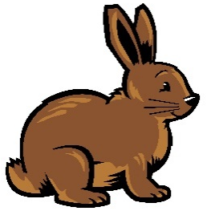  Rabbit Class Spring Term  Please bring in your water bottle daily, this will be sent home for washing at the end of each day.  PE Days:  Tuesday and Wednesday - Please come to school in your PE kit. (Please refer to School Uniform Policy)  Reading Books:  Reading books will be changed every Friday. Children will read their book in school before taking their book home. Children should read at least 3 times at home. Children need their book and planner with them everyday.  Times Table Rock Stars:  Rabbit class have all been given their login details for Times Table Rock Stars. They should be practising their 2, 5, and 10 times tables by accessing the TTRS website at home at least twice a week.  Focus for our learning this term:  English: Poetry, Non-Chronological reports, Invitations, Recount from personal experience, Simple retelling of a narrative. The Quangle Wangle’s Hat, Coming to England, Somebody Crunched Colin, Rhythm in the Rain, The Sun and the Wind.  Maths: Mass, Capacity and Temperature, Multiplication and Division, Money.  Geography: Study Human and Physical Geography of a Small Area of United Kingdom, and of a Contrasting Non-European Country  History: History of Newmarket  Science: Use of everyday materials, Plants | Rabbit Class Spring Term  Please bring in your water bottle daily, this will be sent home for washing at the end of each day.  PE Days:  Tuesday and Wednesday - Please come to school in your PE kit. (Please refer to School Uniform Policy)  Reading Books:  Reading books will be changed every Friday. Children will read their book in school before taking their book home. Children should read at least 3 times at home. Children need their book and planner with them everyday.  Times Table Rock Stars:  Rabbit class have all been given their login details for Times Table Rock Stars. They should be practising their 2, 5, and 10 times tables by accessing the TTRS website at home at least twice a week.  Focus for our learning this term:  English: Poetry, Non-Chronological reports, Invitations, Recount from personal experience, Simple retelling of a narrative. The Quangle Wangle’s Hat, Coming to England, Somebody Crunched Colin, Rhythm in the Rain, The Sun and the Wind.  Maths: Mass, Capacity and Temperature, Multiplication and Division, Money.  Geography: Study Human and Physical Geography of a Small Area of United Kingdom, and of a Contrasting Non-European Country  History: History of Newmarket  Science: Use of everyday materials, Plants

