


Reception Welcome Pack
September 2025



Contents

Page 4 | Welcome Message from the Headteacher
Page 5 | Early Years Welcome Message
Page 6 | Your Class Teachers
Page 7 | Being ready for school
Page 8  Page 9  Page 10 | Settling into School  Our routine  Packed Lunches
Page 11 | What our learning looks like
Page 12-13  Page 14  Page 15 | The Early Years Foundation Stage at Laureate  What to Bring with You  Reception Class – Important Information
Page 16-18 | What people say about Laureate
Page 19 | Laureate Community Academy Aims & Values
Page 20  Page 21 | PTA (ACT)  Contact details

Welcome Message from the Headteacher

Dear Parents/Carers
On behalf of all the staff and governors, I would like to welcome you and your child to Laureate. We are incredibly proud of our friendly, inclusive school community, and we are sure that you will have a fantastic seven years with us. Mrs Bursey and her team are hugely experienced, and will do everything possible to make your child feel safe and happy – it’s often the parents who are more worried than the children! If there is anything specific that we need to know about your child, or if there is anything at all that you’re unsure about, please do not hesitate to let us know as soon as possible so that we can address any concerns. You’re joining a community of over 250 children, with a wide range of first languages (26 at the last count!), nationalities, cultures and faiths, and we can’t wait to see what your child will bring to our school. Our aims and values are encapsulated in our REACH acronym: we want everyone involved at Laureate to Respect each other, Enjoy their time in our school, Aspire to fulfil their potential, learn how to Communicate effectively and lead a happy and Healthy lifestyle. If your child leaves us having achieved all of these, we’ll be delighted – and hopefully you will be too! I look forward to meeting you properly over the coming weeks.

Mr D Perkins
Headteacher


Early Years’ Welcome Message

Hello and welcome to the Early Years at Laureate!

On behalf of all our team I want to welcome you to our school. I have worked at Laureate for over 12 years and have been the Special Needs Co-ordinator (SENDCo) for the school and nursery as well as a member of the school senior leadership team for 7 years. We are a team of experienced and qualified staff who are passionate about ensuring all children are happy, safe and settled at Laureate. We do this through a nurturing environment, high quality planning and provision and we strive to have positive and strong relationships with all our families.

We are excited to get to know you all and look forward to welcoming you all to Laureate in September.

Mrs. E Bursey
Early Years Leader



Your Class Teachers

Mrs. Bursey: I teach Reception in Bumblebee Class and have worked at Laureate for over 10 years. I have taught in nursery, reception, and year 1 during this time. I have also been the school special needs co-ordinator (SENDCo) for over 7 years and the Early years Leader for the last 2 years. I did my teaching qualification with an Early Years specialism, and I have experience working with children from 6 months upwards.
When not at work, I enjoy spending time with my family and friends.

Mrs Young: I teach Reception in Bumblebee Class and have worked at Laureate for over 15 years. I am also the school art and DT lead. I enjoy spending my spare time with my family and friends who I am very lucky to be surrounded by. I like to eat out, travel, explore new places, bake and go walking.





Mrs Mower: I teach in Nursery and Reception as well as helping
children who need specialist or additional support with their
learning and development. I lead the Early Years at Laureate and also
enjoy sharing my knowledge and experience wider as a Lead
Practitioner. Away from school, I am a caring mum, I like to train
and walk my rescue dog, dance, get muddy doing the
garden, cycle and be creative.

Mrs Mower: I teach in Nursery and Reception as well as helping
children who need specialist or additional support with their
learning and development. I lead the Early Years at Laureate and also
enjoy sharing my knowledge and experience wider as a Lead
Practitioner. Away from school, I am a caring mum, I like to train
and walk my rescue dog, dance, get muddy doing the
garden, cycle and be creative.

Being Ready for School

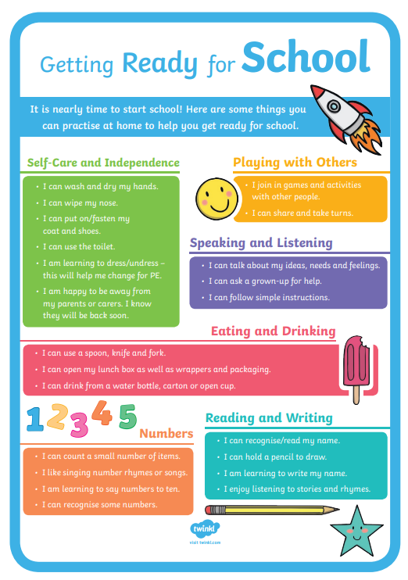

Settling into School
The early days at school can be a lot of change to get used to for both you and your grown-ups. There are things you can do to make it easier. Here are some tips:
Before you start school:
- Start by chatting with your grown up about going to school. See if you can spot other children on their way to school and ask your grown up to read stories about going to school. Newmarket library should have some if you ask. Newmarket - Suffolk Community Libraries Newmarket Library, 1a the Guineas, Newmarket
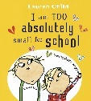
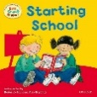

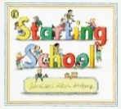
- Next, get involved in choosing your uniform. It is a good idea to choose clothes and shoes that are easy for you to get on and off. Your teacher will tell you what days you will have your P.E lessons, and put this in your home school planner. On your P.E days, you must come to school wearing your P.E kit. A copy of the uniform expectations was sent with this Welcome Pack. Your P.E t-shirt must be in your house colour which will be confirmed to your grown up. If you have long hair, it must be tied back; if you wear earrings, these need to be removed.







- Many children are worried about school lunches, so we will send you an example menu so you can talk to your grown up about how fun it will be choosing what you have to eat every day. If you are going to have packed lunches, pack them together.
- Get to know your teacher well right from the beginning and let them know if there is anything worrying you, they are here to help you settle into school. Ask them lots of questions about what you’ll be doing at school.

- Help your grown-up label all of your things, especially your uniform and water bottle. It can be tricky to find your jumper otherwise.

Once you have started school:

- Ask your grown up to arrange for you and one or a group of your new school friends to play together out of school.

- Your grown up, will be given login details for Tapestry, this is where your teachers will add weekly class updates about your learning for your grown-ups to look at and read.

- Talk to your grown up about what you have been doing at school so they can support your learning, and grown-ups love to hear about all the exciting things you will have been doing at school.

- Read your home reading books with your grown up and ask them to write it in your home school planner; include any comments that they would like your teachers to know.

Our Daily Routine

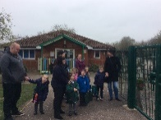
The school day starts at 8:50am and ends at 3:30pm, the school gates and registration close at 9:00am.
When you arrive at school, please wait near the big green gates near the Early Years building with your grown up until a member of school staff opens the gate. Once the gate is opened, come round to your classroom gate which is located jus off the main playground, where you will have waited on your move up days.
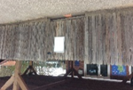
This is our classroom gate. If it’s raining and the door is not open, you can stand under the wooden shelter outside our classroom.

Snack time is between 10:00 and 11:00am. You will be given a piece of fruit or a vegetable along with a cup of milk, or water, you can have a drink of water whenever you need one during explore time. Snack is also available during the afternoon if you get hungry then.

Lunch is from 12.00pm until 12.50pm. You can choose to have a school dinner or a packed lunch.
One of your teachers or teaching assistants will walk you from our classroom to the dinner hall where you will be seated in the school dinner or packed lunch area.

An adult from your class will stay with you in the dinner hall for the first few days to make sure you’re OK. The lunch staff will look after you while you eat and when you have finished your lunch, a teaching assistant or midday supervisor will walk you back to your class. You will then be able to play outside until the end of lunchtime.

At 3:30pm, your grown up will be allowed onto the main playground and will wait for you at the same wooden gate they dropped you off at in the morning. We will make sure that we recognise the person collecting you. If your grown up is late, we will keep you with us for a short time and then take you to the main school office. Your adult should tell the school office if they know they are going to be late and/or if someone else is going to be collecting you.

Packed Lunches



Please note that we are a Nut Free School so no products containing nuts can come into school, please ask your grown up to check the labels on your food.

THIS SCHOOL IS
NUT FREE

THANK YOU
for keeping our school safe!

We do ask that all packed lunches are healthy and balanced meals for your child. These should not include any chocolate or sweets please.


If you want any help or advice on how to make a healthy packed lunch we recommend looking at the NHS website where it has some good ideas. Lunchbox ideas and recipes – Healthier Families - NHS (www.nhs.uk)

What our inside classroom learning can look like…

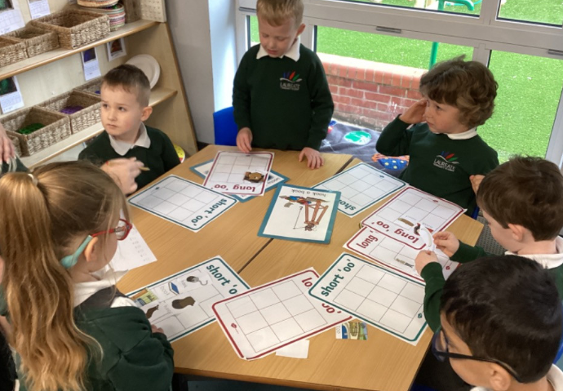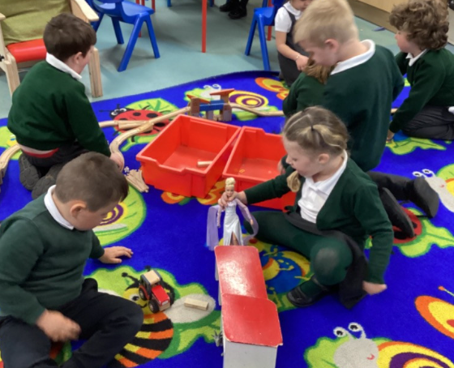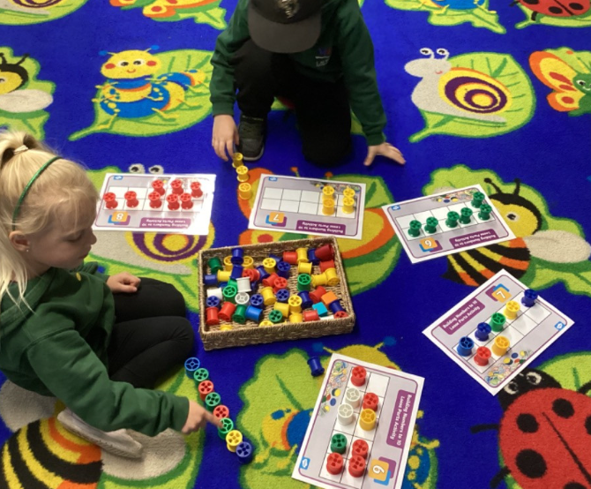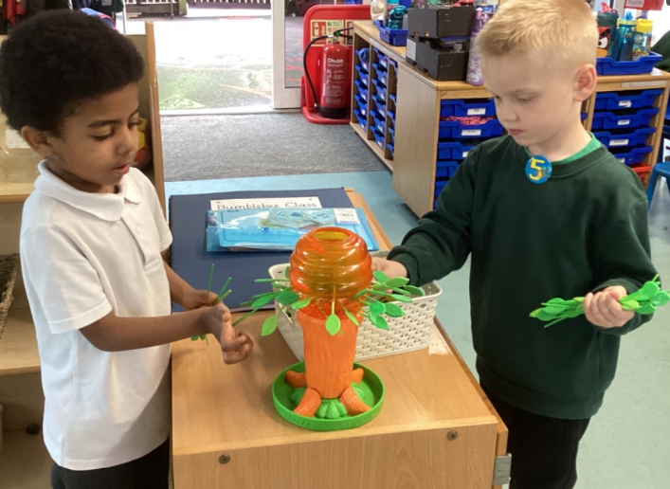
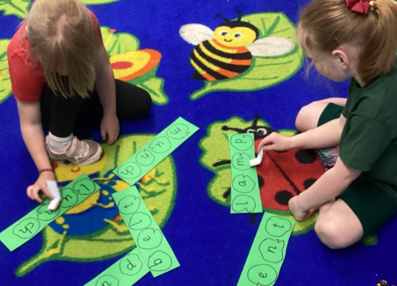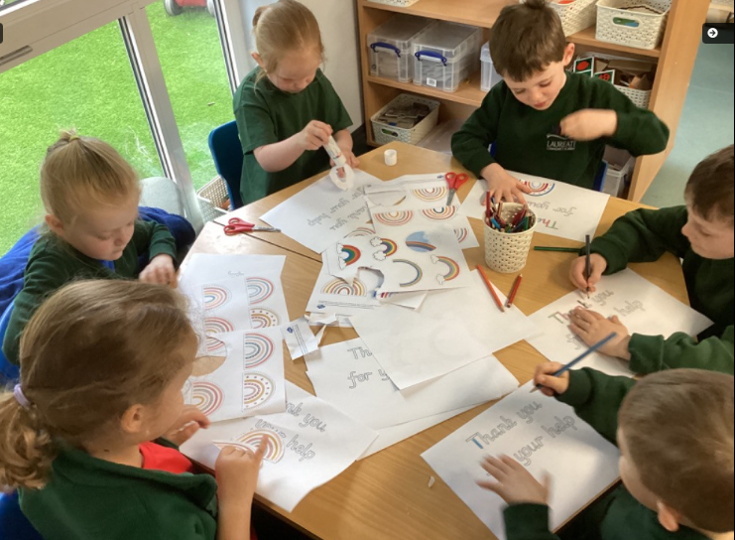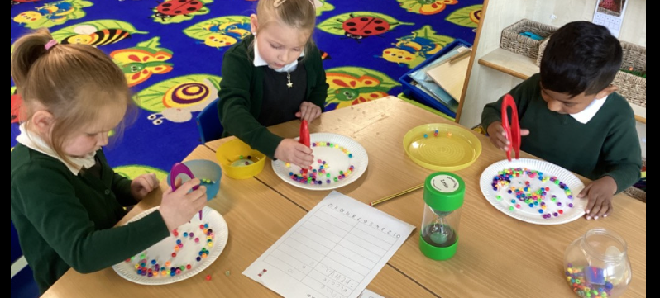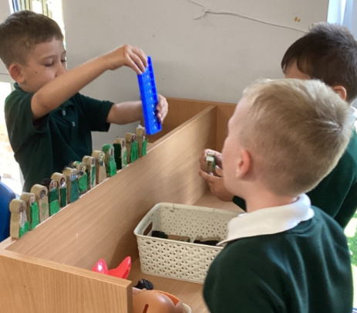

What our outdoor learning can look like…

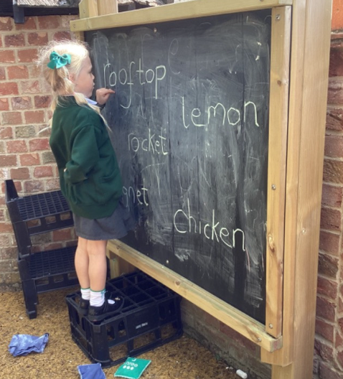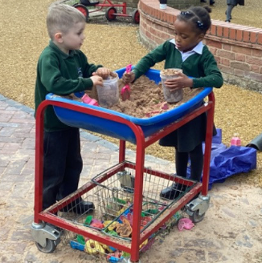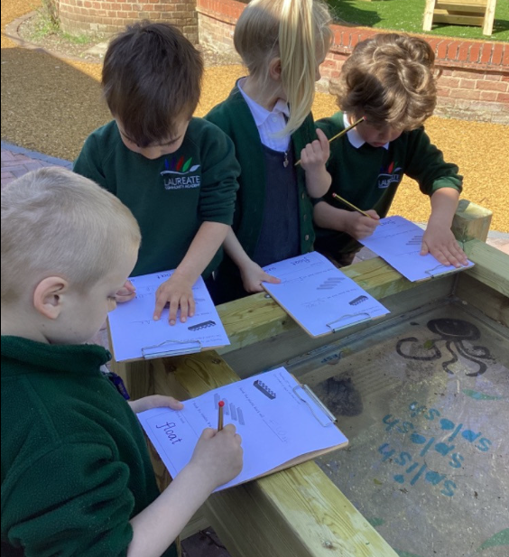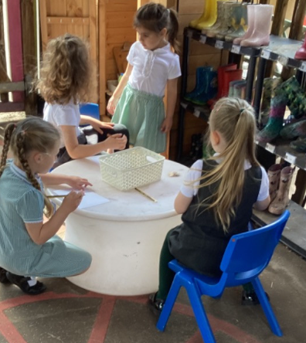
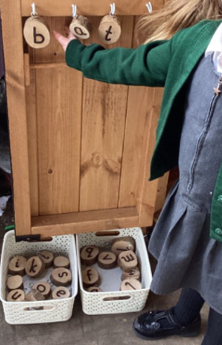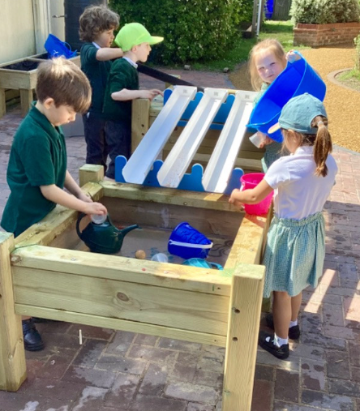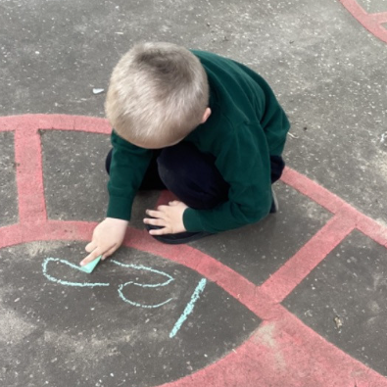

The Early Years Foundation Stage at Laureate
Children develop more rapidly during the first five years of their lives than at any other time. Well-planned play and rich experiences supported by quality and timely teaching interactions are keyways in which young children learn with enjoyment and challenge, and this is our approach at Laureate. We foster independence and important life-long
ride bicycles, dig, play imaginatively and explore whatever the weather. We value and encourage parents and carers to take an active interest in their child’s education and offer lots of opportunities for them to do so through share sessions and projects. We use the Early Years Foundation Stage guidance, tailored to each child’s needs and led by their interests as a basis for learning and development in the following areas:
- Communication and Language

- Physical Development

- Personal, Social and Emotional Development

- Literacy

- Mathematics

- Understanding the World

- Expressive Arts and Design

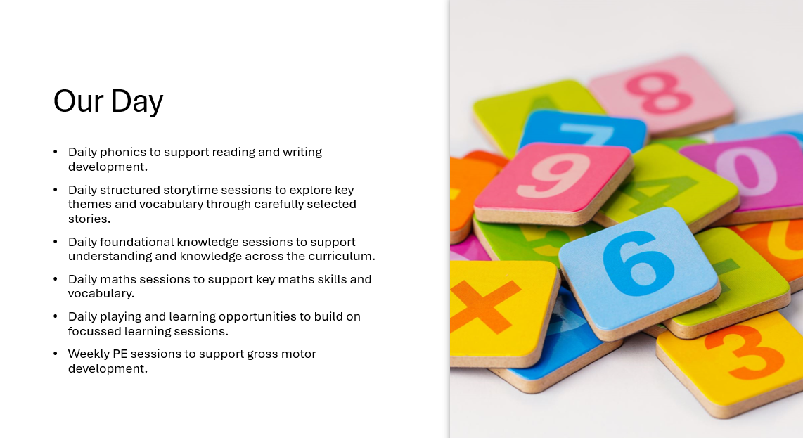

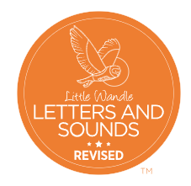
We use the Little Wandle scheme to teach phonics. This is the programme to help your child learn to read by connecting sounds with letters or groups of letters.


We follow our Trust’s curriculum programme called CUSP. This provides us with structured storytime sessions which we link with the foundational knowledge focus of each week. We then plan your child’s opportunities and experiences around this.


For Maths we follow the mastering number programme which uses the Numberblocks from CBBC as a focus to help as fun characters to learn key numerical skills through.

What to Bring with You.

On your first day, remember to bring:

A water bottle with your name on it; you can leave it in your
classroom and take it home at the end of each day.

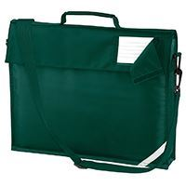
A book bag with your name on it.

If you choose to have a packed lunch, please make sure your lunch box/bag has your name written on it clearly.

Every day you should remember to bring:


Your water bottle.


Your book bag.

Your independent reading book. 

Spare clothes (and some nappy bags!) in case of toileting accidents or enthusiastic play in the water tray!

Reception Class – Important Information

Wraparound Club
Here at Laureate our wraparound club is provided by Prestige Sports Development. The wraparound service offers breakfast club and after school club, Monday to Friday. Prestige wraparound club is designed to offer a safe space for children through a range of activities including sports, arts and crafts and more.

- Breakfast club runs from 8:00am until 8:50am (the start of the school day) and is charged at £4.00 per day.
- After school club runs from 3:30pm until 6:00pm, the cost for this club is:
- £4.50 for 3:30pm until 4:30pm
- £7.00 for 4:30pm until 6:00pm

To book please follow the instructions below.
1. Follow link: https://prestige-wrap-around-club.classforkids.io/camp/19
2. Click on ‘select dates to book’ and choose the dates you require
3. Click choose child and add your child.
4. This will then take you through to the payment page.

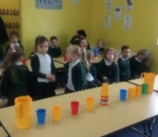
If you are in receipt of Free School Meals (excluding Universal Infant Free School Meals), please email the school office for a booking code. Spaces on these clubs are limited and are taken on a first come first served basis. Advanced booking is required, anyone not booked on, may be turned away.

Free School Meals
We have included a ‘Free School Meal - What’s in it for me?’ leaflet for you to look through. If you believe you may be entitled to free school meals, please follow the instructions on the explanatory leaflet.

Caterlink – School Dinners

Caterlink are specialist caterers within schools. We’re passionate about fresh, healthy food that tastes great. The right nutrients can affect everyone’s mood, behaviour, health, growth and even their ability to concentrate. Encouraging a well-balanced diet establishes healthy eating now and for the future.

The current school dinner menu is available on our website. All pupils up to the end of Year 2 are currently entitled to Universal Infant Free School Meals (this is different to the above-mentioned Free School Meals).

If you have any special dietary requirements or allergies, please make sure that your grown up adds this information to the All About Me booklet, so our Head of Kitchen can make sure your lunch means your needs.
Policies/Safeguarding
Copies of all our policies and information regarding Safeguarding can be found on our website at www.laureateacademy.co.uk
If you require any further information on these or any other matters, please do not hesitate to speak to a member of the School Office team.
What Ofsted say about Laureate

Pupils’ personal development is a strength.

Pupils enjoy learning an ambitious curriculum.
Pupils and staff at Laureate Community Academy shine.

Pupils care about each other and treat each other with respect.
Pupils’
well-being is a priority.
Ofsted comments, January 2025

Pupils are inclusive and value the diversity of the school population.
In the early years, children are confident and settled.
Pupils with special educational needs and/or disabilities (SEND) have well-planned support.

“The way you teach the children. Learning through play is the best for them.”

“Always a fun and safe learning environment.”
“The parent share sessions are brilliant. They are really fun.”
“That I still get time to spend with my child during school.”

“Everyone is so friendly and helpful.”
What our parents and carers love about the Early Years at Laureate

“My son’s first experience of school was in reception at Laureate Community Academy and Nursery. From day one he was given the support he needed to learn, make new friends and most importantly feel proud of his achievements from learning to read to constructing wonderful junk models and even problem solving. The teachers were always approachable and supportive to both my son and to me as a parent. We had the opportunity to attend some lovely share sessions which enabled the children to show us what they were doing in class and offered parents the chance to see how they could support their children’s learning. He continues to thrive at Laureate, and I highly recommend this setting to any parent questioning which school to choose.”



“I like school because it has special days; share sessions.”

“I like playing in the garden.”

“I like being kind to my friends.”

What do our children love about the Early Years at Laureate

“I like making.”
“I like sharing with my friends.”

“I like playing with my friends.”




Laureate Community Academy Aims & Values

Respect, Enjoy, Aspire,
Communicate, be Healthy

At Laureate, we are determined to create an inclusive learning community where everyone is given the opportunity to fulfil his or her potential. We aim to challenge and support all of our pupils, helping them to become lifelong learners and preparing them for life in modern Britain. This is encapsulated in our ‘REACH’ acronym: We want everyone involved at Laureate to Respect each other, Enjoy their time in our school, Aspire to fulfil their potential, learn how to Communicate effectively and lead a happy and Healthy lifestyle.
Respect | - Pupils say: We will treat people how we would like to be treated, be kind to everyone and value everyone else’s beliefs and ideas.  - Parents say: We want our children to be taught what it means to respect each other and to learn to respect their peers, including their differences in faith, culture etc.
Enjoy | - Pupils say: We want to have a good time at school and make our learning fun, but we also need to think about the consequences of our actions.  - Parents say: We want our children to look forward to coming to school and to enjoy all of their learning, not just their favourite subjects.
Aspire | - Pupils say: We will reach high to try to achieve our goals and leave our comfort zone in order to go beyond our limits.  - Parents say: We want our children to be inspired to challenge themselves and each other in order to continuously improve, and to widen their awareness of what’s possible for them in the future.
Communicate | - Pupils say: We know that we have to learn well with our friends and be good team members; we need to think before we speak so that we don’t upset anyone.  - Parents say: We want our children to be able to work as part of a team, to listen to each other, to verbalise their feelings and resolve disagreements in a positive way.
(Be) Healthy | - Pupils say: We need to understand the importance of taking care of ourselves, both mentally and physically, so that we develop strong bodies and minds.  - Parents say: We want our children to have regular opportunities to move and enjoy being active, and to respect themselves in their choices of food, drink, exercise and relaxation.

The staff and governors at Laureate recognise the positive contribution of all members of our diverse school community. Our aim is to provide the best possible education according to individual needs in a caring and supportive environment where diversity of ability, gender, culture and belief is valued and celebrated.


PTA (ACT)
Laureate School Parent Teacher Association

The school has a dedicated PTA (Parent and Teacher Association), also known as the ACT (Adults & Children Together), of which all parents and teachers are automatically members.

There are regular meetings, to which all parents are invited. The association fosters educational, social and fundraising events. We are proud to say that the school has a strong tradition of parental support, where the PTA regularly get involved with fundraising for specific purposes, to be able to fund things which will benefit our children. Support towards school trips and many extra items of equipment (including computers, library books and P.E. and sports equipment) through money raised by parents and teachers working together in recent years.

We also have regular second-hand uniform sales, so just ask a member of the PTA if you need any additional unform.

Ways you can help
Join our School Lottery
For every £1 spent on our lottery, the school receives 40% and one lucky winner out of our supporters wins 30%. If the whole school plays, then the winner’s prize stands to be over £60 each week!! Please go to the following webpage and search for Laureate: https://www.yourschoollottery.co.uk/play

Easy Fundraising
Our PTA is also registered with easyfundraising.org.uk - order online from over 2,000 retailers (including Amazon, M&S and John Lewis) and when you make a purchase, they donate to your chosen cause. Sign up today to start supporting our PTA.

Naming your child’s clothes - for every purchase from stamptastic, the school receives commission. Please use the PTA code CB80AN
https://stamptastic.co.uk

Toucan Box - will deliver a trial craft box to your door for your child at the cost of £1, subscription is required but very easy to cancel after the trial box has been received. For every box ordered, the school will receive £5
https://signup.toucanbox.com/?code=laureateacademyschool

Finally, we do ask that you come and support our events, whether by buying a cake, bringing your child to a party or coming along to see Santa at the Christmas Fair. These events really do help make a difference to the daily lives of
all our children.

Please join us on our Facebook page, Facebook Noticeboard and our noticeboard at the front of the school to keep up to date about upcoming meetings, our events and fundraising, we will also use this page to keep you informed of what we are raising money for next year.
Laureate PTA - https://www.facebook.com/laureate.pta.1
Laureate Community Academy and Nursery PTA Noticeboard - https://www.facebook.com/groups/636240403241466

To find out more about the PTA, please speak to a member of the PTA committee, or to the office staff who will be happy to point you in their direction. Please come along to the next PTA meeting, where we welcome all parents to get involved and share any ideas or views you may have.

Contact Details

Headteacher:
Mr David Perkins

Deputy Headteacher/Designated Safeguarding Lead:
Mrs Cath Dalton

Early Years Lead/SENDCo
Mrs Ellie Bursey

Office Staff:
Mrs Lisa Schorer-Nixon - School Operations Manager
Mrs Corinne Hawes - Office Administrator
Miss Antoinette Still - Finance Administrator

Office Contact Number
01638 663927

Office Email Address
admin@laureateacademy.co.uk

School Address
Exning Road, Newmarket, Suffolk, CB8 0AN

